Electronic supplementary information

**USE OF PHENYL-SUBSTITUTED CYCLOPENTADIENYL  
RHODIUM COMPLEXES IN the C–H ACTIVATION**

V. B. Kharitonov, Yu. V. Nelyubina, and D. A. Loginov*

Nesmeyanov Institute of Organoelement Compounds, Russian Academy of Sciences,  
ul. Vavilova 28, str. 1, Moscow, 119334 Russia

**Table of contents**

1. General experimental remarks S2
2. NMR spectra S3
3. Computational details S4
4. X-ray diffraction study S6
5. References S7

**General experimental remarks**

All reactions were carried out under air using distilled solvents. Isolation of all products was carried out in air. The rhodium complexes [Cp*RhCl2]2, [CpPh2RhCl2]2 and [CpPh3RhCl2]2 were synthesized according to published protocols [1]. All other reagents were purchased from Acros or Aldrich and used as received. Column chromatography was carried out using Macherey-Nagel silica gel 60 (particle sizes: 0.04−0.063 mm). The 1H and 13C{1H} NMR spectra were recorded on a Varian Inova 400 spectrometer operating at 400 and 101 MHz, respectively. The chemical shifts are given in ppm using the residual solvent signals as an internal standard. The HRMS spectrum (ESI) was recorded using a TripleTOF 5600+ mass spectrometer (SCIEX).

**Rhodium-catalyzed reaction of 4-methyl-*N*-(pivaloyloxy)benzamide with norbornene**

4-Methyl-*N*-(pivaloyloxy)benzamide (23.5 mg, 0.1 mmol, 1 equiv.), rhodium complex (1 mol %), CsOAc . (4.8 mg, 0.025 mmol, 0.25 equiv.), AgOAc (2 mg, 0.01 mmol, 0.1 equiv.), and solvent (1 mL) were placed in a tube equipped with a magnetic stirring bar. After 5 min, norbornene (19 mg, 0.2 mmol, 2 equiv.) was added. The reaction mixture was stirred at room temperature for 1 h. For the NMR sepctroscopic monitoring, after the evaporation of the solvent, the residue was dissolved in DMSO-*d*6. The conversion was determined as the ratio of the integrals of Me proton signals of the target product and the starting benzamide.

For the isolation of compound **1**, in the case of [CpPh2RhCl2]2 (0.8 mg, 1 mol %), after stirring the reaction mixture for 1 h, the solvent was removed under vacuum without heating, and the residue was purified by chromatography on silica gel (1 × 15 cm). The first colorless band containing the unreacted alkene was eluted with CH2Cl2. The second band was eluted with CH2Cl2–EtOAc (4:1) to give target compound **1** as a colorless solid. Yield: 22.5 mg (99%).

**9-Methyl-1,3,4,4a,5,10b-hexahydro-1,4-methanophenanthridin-6(2*H*)-one (1)**



1H NMR (400 MHz, CDCl3): *δ* 7.96 (d, *J* = 8.1 Hz, 1H), 7.07 (d, *J* = 7.3 Hz, 1H), 7.03–6.99 (m, 1H), 6.48 (s, 1H), 3.77 (d, *J* = 8.5 Hz, 1H), 3.05 (d, *J* = 9.1 Hz, 1H), 2.35 (s, 3H), 2.32–2.27 (m, 1H), 2.25–2.21 (m, 1H), 1.68–1.59 (m, 3H), 1.54–1.44 (m, 1H), 1.34–1.27 (m, 1H), 1.18–1.11 (m, 1H). 13C{1H} NMR (101 MHz, CDCl3): δ 164.1, 142.9, 140.5, 129.0, 127.5 (2C), 123.5, 58.4, 47.9, 46.4, 44.3, 32.6, 30.2, 25.8, 21.7. HRMS (ESI) *m/z*: [M+H]+ calcd for C15H18NO 228.1383; found, 228.1386.

**NMR spectra**

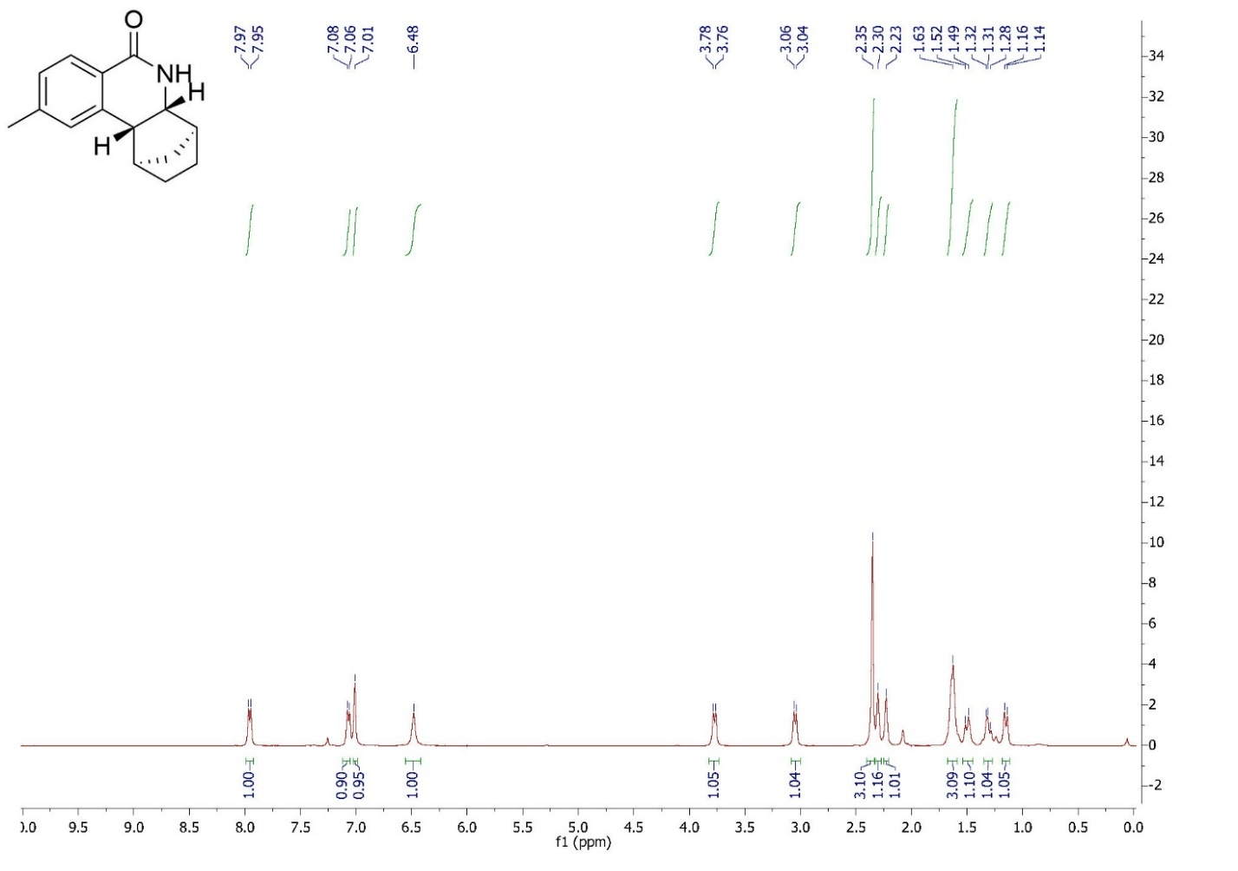

1H NMR (400 MHz) spectrum of **1** in CDCl3

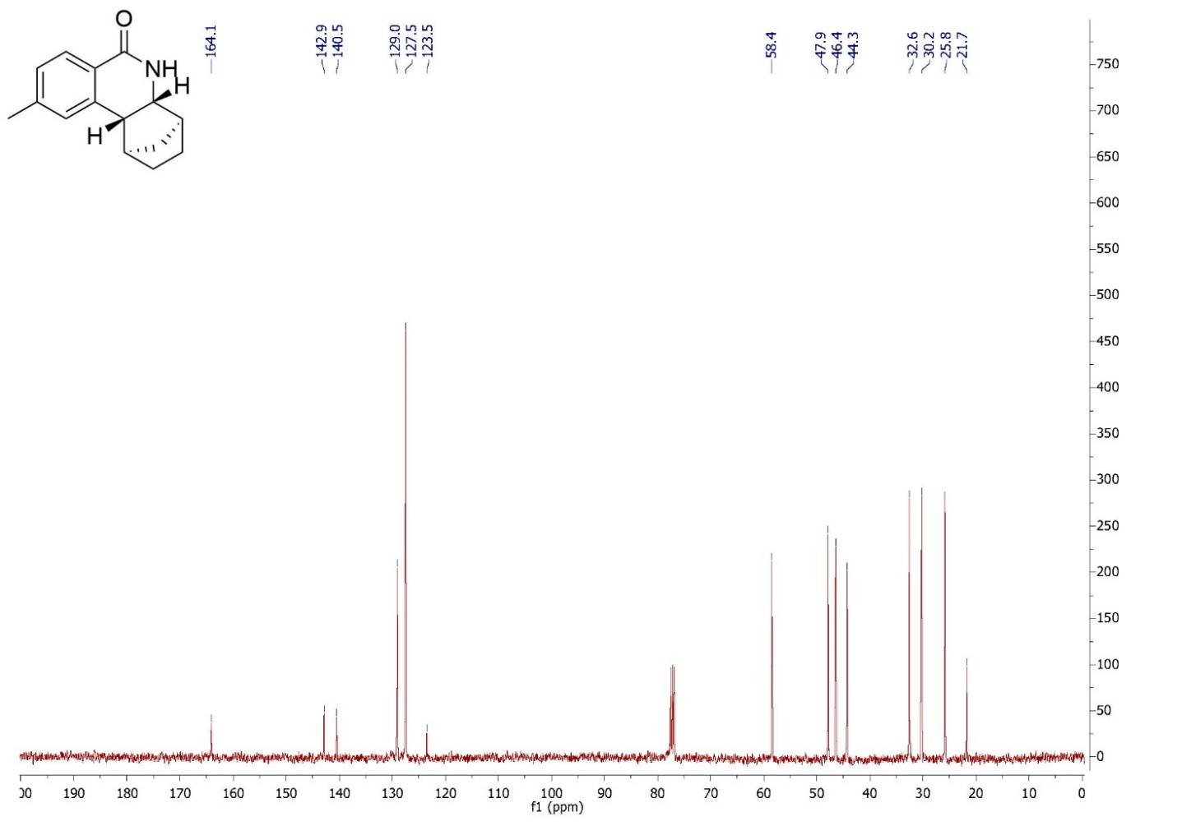

13С NMR (400 MHz) spectrum of **1** in CDCl3

**Computational details**

All calculations were performed using ADF 10 program at the GGABP-D3/TZP level with corrections for solvation in methanol (the COSMO model implemented in the ADF 10 program).

To estimate the stabilization effect of cyclopentadienyl ligand on the Rh−Cl bonding, we performed energy decomposition analysis (EDA) for complexes of the type [CpRRhCl2(MeOH)] at the GGABP-D3/TZP level using the COSMO solvation model with methanol as a solvent (Table S1). According to the EDA Scheme [2] the energy of interaction between two fragments of the molecule Δ*E*int can be divided into three main components: Δ*E*int = Δ*E*elstat + Δ*E*Pauli + Δ*E*orb, where *E*elstat is the electrostatic attraction between the fragments with a frozen electron density, Δ*E*Pauli is the repulsive interactions between occupied orbitals (Pauli repulsion), and Δ*E*orb is the stabilizing orbital interactions. We found that the interaction energy (ΔEint) of the bonding between the [CpRRh(MeOH)]2+ fragment and two chlorine anions is higher by *ca*. 4 kcal mol–1 for the Cp* derivative than for the CpPh2 derivative. Although the sum of attractive interactions (ΔEelstat + ΔEorb) for the complex with CpPh2 is higher than that with Cp*, this positive effect is overruled by an increase in the ΔEPauli value for the CpPh2 derivative, indicating a significant contribution of steric effects to Rh-Cl bonding.

**Table S1.** Results of energy decomposition analysis (energy values in kcal mol–1) for [CpRRhCl2(MeOH)] with [CpRRh(MeOH)]2+ + [Cl2]2–as interacting fragments at the GGABP-D3/TZP level

|  |  |  |  |  |  |
| --- | --- | --- | --- | --- | --- |
| CpR | ΔEint | ΔEelstat | ΔEorb | ΔEelstat + ΔEorb | ΔEPauli |
| Cp* | –467.39 | –432.50 | –114.64 | –547,14 | 125.15 |
| CpPh2 | –463.28 | –421.64 | –138.32 | –559,96 | 140.25 |

**Cp*RhCl2(MeOH)**

1.Rh -0.930495 0.086480 -0.149368

2.H 1.728282 -1.389745 -2.172817

3.H 2.960139 1.503533 -1.139103

4.C 0.472518 -1.105397 1.066251

5.H 0.724953 3.315302 0.363474

6.C 1.098112 -0.800757 -0.196025

7.C 1.216740 0.648001 -0.290519

8.C 0.153134 0.144084 1.728410

9.H -1.052729 1.206285 3.150199

10.H -0.607322 -2.485245 2.314084

11.C 0.646160 1.229948 0.892031

12.Cl -2.733179 1.764353 0.305282

13.H -0.325874 2.937659 1.750120

14.H 1.442657 2.899921 1.936140

15.C -0.440468 0.299328 3.087619

16.H -1.059095 -0.562774 3.359813

17.H 0.369001 0.384786 3.830227

18.Cl -2.613937 -1.764490 -0.352157

19.C 0.233648 -2.470932 1.612861

20.H 0.038155 -3.195350 0.814890

21.H 1.136597 -2.795613 2.155079

22.C 1.651086 -1.798114 -1.159497

23.H 2.663466 -2.093277 -0.840879

24.H 1.036669 -2.705348 -1.194808

25.C 1.892404 1.394495 -1.389914

26.H 1.836921 0.860065 -2.344537

27.H 1.474836 2.398970 -1.517976

28.C 0.612634 2.677648 1.246862

29.O -1.625905 0.375137 -2.367079

30.H -2.490002 -0.063567 -2.196407

31.C -0.923243 -0.456947 -3.333841

32.H -1.454005 -0.438908 -4.294631

33.H -0.836096 -1.489021 -2.967008

34.H 0.071491 -0.019645 -3.461176

**CpPh2RhCl2(MeOH)**

1.Rh 1.457030 -0.232598 0.119934

2.Cl 3.660482 -1.365112 -0.046478

3.H -5.044021 -1.508474 0.411055

4.H -4.626924 -3.693491 -0.719108

5.Cl 0.843739 -0.959603 -2.169269

6.C -0.516544 -0.749993 1.065199

7.C 0.594990 -1.338498 1.773869

8.C 1.404561 -0.281004 2.320008

9.C 0.846737 0.951196 1.891538

10.C -0.341739 0.693483 1.099067

11.H 0.732484 -2.402196 1.938244

12.H 2.297696 -0.405450 2.923060

13.H 1.258354 1.936521 2.092311

14.C -1.191191 1.733290 0.502917

15.C -1.411240 2.933434 1.202453

16.C -1.770718 1.558897 -0.769126

17.C -2.222210 3.930039 0.652338

18.C -2.570204 2.559452 -1.318248

19.C -2.804167 3.745323 -0.607161

20.H -0.964090 3.075377 2.186831

21.H -1.561090 0.646683 -1.329180

22.H -2.397569 4.851341 1.208128

23.H -3.007739 2.418060 -2.306294

24.H -3.433255 4.525529 -1.037150

25.C -1.630683 -1.524477 0.502976

26.C -1.399753 -2.763043 -0.124366

27.C -2.951289 -1.073947 0.681717

28.C -2.473924 -3.533607 -0.568351

29.C -4.023839 -1.857346 0.251154

30.C -3.788332 -3.085055 -0.378636

31.H -0.376500 -3.101263 -0.284072

32.H -3.135342 -0.121773 1.178917

33.H -2.287211 -4.486203 -1.064265

34.O 2.473571 1.382073 -1.126532

35.H 2.338293 0.893479 -1.974345

36.C 1.745563 2.642149 -1.244192

37.H 2.234813 3.270651 -1.999159

38.H 1.797889 3.127481 -0.265063

39.H 0.696278 2.463236 -1.516346

**X-ray diffraction study**

Crystals of **1** were grown by slow evaporation of a solution in dichloromethane. X-ray diffraction data were collected at 120 K with a Bruker APEX2 CCD diffractometer, using graphite monochromated Mo-Kα radiation (l = 0.71073 Å, ω-scans). Using Olex2 [3], the structure was solved with the ShelXT [4] structure solution program using Intrinsic Phasing and refined with the XL [5] refinement package using Least-Squares minimization against F2 in the anisotropic approximation for non-hydrogen atoms. Hydrogen atom of the NH group was located from difference Fourier synthesis while positions of other hydrogen atoms were calculated, and they all were refined in the isotropic approximation in the riding model. Crystal data and structure refinement parameters are given in Table S2. CCDC 2385702 contains the supplementary crystallographic information for **1**.

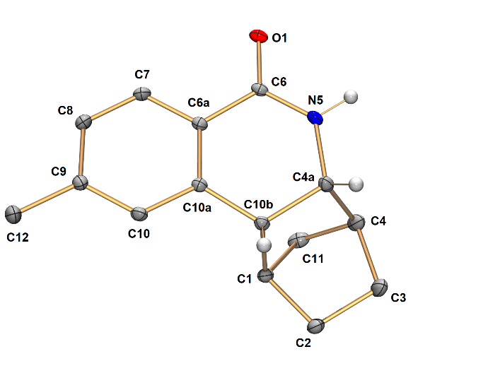

**Figure 1**. General view of **1** in representation of atoms as thermal ellipsoids (*p* = 50%); the hydrogen atoms, except those at the carbon atoms C4a and C10b and in the NH group, are omitted. Bond lengths [Å]: O1–C6 1.2478(15), C4A–C10B 1.5594(18), N5–C4A 1.4661(16), C6–C6A 1.4831(17), N5–C6 1.3343(17), C6A–C7 1.3980(18), C1–C2 1.5317(18), C6A–C10A 1.3923(17), C1–C10B 1.5561(17), C7–C8 1.3805(19), C1–C11 1.5293(19), C8–C9 1.3995(18), C2–C3 1.552(2), C9–C10 1.3888(18), C3–C4 1.5442(19), C9–C12 1.5030(19), C4–C4A 1.5390(19), C10–C10A 1.3935(18), C4–C11 1.535(2), C10A–C10B 1.5079(17).

**Table S2.** Crystal data and structure refinement parameters for **1**

|  |  |
| --- | --- |
|  | **1** |
| Formula unit | C15H17NO |
| Formula weight | 227.29 |
| Crystal system | Monoclinic |
| Space group | P21/n |
| Z | 4 |
| a, Å | 10.745(2) |
| b, Å | 9.972(2) |
| c, Å | 12.161(2) |
| α, ° | 90 |
| β, ° | 114.480(5) |
| γ, ° | 90 |
| V, Å3 | 1185.9(4) |
| *D*calc (g cm−1) | 1.273 |
| Linear absorption, *μ* (cm−1) | 0.79 |
| F(000) | 488 |
| 2Θmax, ° | 58 |
| Reflections measured | 13621 |
| Independent reflections | 3149 |
| Observed reflections [*I* > 2σ(*I*)] | 2378 |
| Parameters | 155 |
| R1 | 0.0463 |
| wR2 | 0.1258 |
| GOOF | 1.066 |
| Δ*ρ*max/Δ*ρ*min (e Å−3) | 0.346/–0.261 |

**References**

1. (a) V. B. Kharitonov, D. V. Muratov, A. N. Rodionov, Yu. V. Nelyubina, M. A. Navasardyan, M. S. Nechaev, D. A. Loginov, *Adv. Synth. Catal*., **2024**, *366*, 4729–4736. DOI: 10.1002/adsc.202400716; (b) V. B. Kharitonov, D. V. Muratov, Yu. V. Nelyubina, I. A. Shutkov, A. A. Nazarov, D. A. Loginov, *J. Org. Chem*., **2023**, *88*, 2869–2883. DOI: 10.1021/acs.joc.2c02526; (c) C. White, A. Yates, P. M. Maitlis, D. M. Heinekey, *Inorg. Synth.*, **1992**, 29, 228–234.

2. For reviews, see: (a) G. Frenking, *J. Organomet. Chem.*, **2001**, *635*, 9–23. DOI: 10.1016/S0022-328X(01)01154-8; (b) G. Frenking, K. Wichmann, N. Fröhlich, C. Loschen, M. Lein, J. Frunzke, V. M. Rayón, *Coord. Chem. Rev.*, **2003**, *238*, 55–82. DOI: 10.1016/S0010-8545(02)00285-0; c) G. Frenking, A. Krapp, *J. Comput. Chem.*, **2007**, *28*, 15–24. DOI: 10.1002/jcc.20543; (d) T. Ziegler, J. Autschbach, *Chem. Rev*., **2005**, *105*, 2695–2722. DOI: 10.1021/cr0307188; (e) M. J. S. Phipps, T. Fox, C. S. Tautermann, C.-K. Skylaris, *Chem. Soc. Rev*., **2015**, *44*, 3177–3211. DOI: 10.1039/C4CS00375F

3. O. V. Dolomanov, L. J. Bourhis, R. J. Gildea, J. A. K. Howard, H. Puschmann, *J. Appl. Crystallogr*., **2009**, *42*, 339–341. DOI: 10.1107/S0021889808042726

4. G. M. Sheldrick, *Acta Crystallogr. A: Found. Adv*., **2015**, *71*, 3–8. DOI: 10.1107/S2053273314026370

5. G. M. Sheldrick, *Acta Crystallogr*., *Sect. A: Found. Crystallogr*., **2008**, *64*, 112–122. DOI: 10.1107/S0108767307043930